week 7 activity 1:

4/11/2014

Alexander Cannell

**p.232: #1, 2, 3. In #3, your program only needs to search a given directory, not an entire tree.**

1. In java the file class is used to represent the data in a directory entry. write a program that uses the file class to print all the attributes of the file.

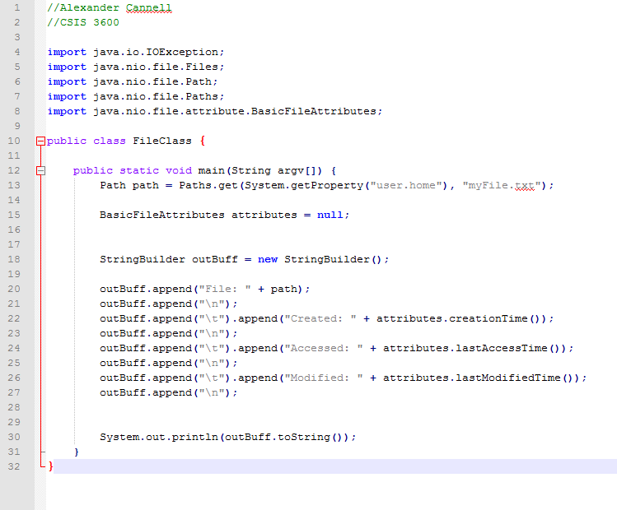

2. write a program that uses each of the I/O systems calls described in teh section on access methods.

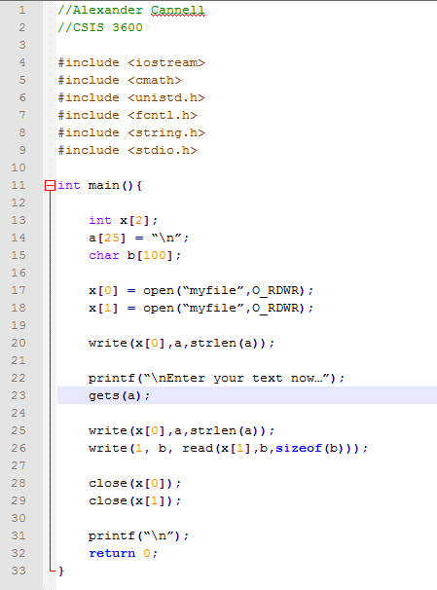

3. write a program that searches a directory tree of a particular file.

